**PUNE INSTITUTE OF COMPUTER TECHNOLOGY, DHANKAWADI, PUNE**



**A MINI-PROJECT REPORT**

***ON***

**PICT TnP MANAGEMENT SYSTEM**

Submitted By

Class **– TE1, TE3**

Batch – **L1, L3**

Semester - **5**

Group Members (Roll No and Name)

**31137 – Vinayak Jamadar**

**31332 – Sangmeshwar Mahajan**

GUIDED BY

**Prof. Vijayendra Bagade**

**Prof. Pranjali Joshi**

**COMPUTER ENGINEERING DEPARTMENT**

**Academic Year: 2022-23**

1. **ABSTRACT:**

*Fast, reliable internet connectivity has also meant a shift in the way IT services are delivered. We’re increasingly seeing a move to the cloud for storing data but also to provide business services. This is an attractive option for enterprises for many reasons. It reduces the need for investment in infrastructure and shifts the day-to-day operational tasks such as back-ups elsewhere. It also better serves mobile workforces, enabling them to access company systems from anywhere.*

*For companies looking for website design, Manchester based Bamboo Solutions may be worth approaching.  Based in Bury they are easily reachable to those in the Manchester area.  Proximity to a designer is key as you may wish to pop in and discuss your plan and how things are progressing.*

*The Online Future*

*But the process of moving online has only just begun. New technologies in smart devices will mean even more information appearing on the internet, perhaps without our realizing that it’s happening. The Internet of Things will mean that many of our household appliances, cars and even clothes will be able to upload data to the web. This will open a new era in monitoring and controlling our homes, our health and more.*

*Of course, there are concerns about how all of this will work, how the fabric of the net will cope with extra traffic and how much of our privacy we’ll sacrifice by allowing our data to be shared. But whatever happens, we can be sure that however influential we think the internet is now, the online revolution has only just begun.*

*Hence, we’re building a database which can be easily accessed and developed through proper modelling, complex design, and techniques. To communicate with the database, we need a Database Management System (DBMS) that creates a bridge between the end user and data. So, in this project, we'll design and implement a relational database to help the faculty of PICT TnP Cell and students at PICT college to maintain the track of progress of performance in the company placement process.*

*The Project ‘****PICT TnP MANAGEMENT SYSTEM****’ not only focuses on placement records, but it also helps the Cell to manage & maintain the data of their students’ performance, companies visited, their intake, criteria, graphs, chart and to develop the placement record sheet.*

1. **TABLE OF CONTENTS**

|  |  |  |
| --- | --- | --- |
| **SR. NO.** | **CONTENT** | **PAGE NO.** |
| 1. | Introduction | 4-5 |
| 2. | Hardware & Software Requirements | 9 |
| 3. | ER Diagrams | 10-11 |
| 4. | Test cases | 12-14 |
| 5. | Results | 15-20 |
| 6. | Conclusion and Future Enhancements | 21 |
| 7. | References | 22 |

1. **LIST OF TABLES**

|  |  |  |
| --- | --- | --- |
| **SR. NO.** | **TABLE NAME** | **PAGE NO.** |
| 1. | Test cases | 12-14 |

1. **LIST OF DIAGRAMS**

|  |  |  |
| --- | --- | --- |
| **SR. NO.** | **DIAGRAM NAME** | **PAGE NO.** |
| 1. | ER Diagram (PICT TnP Platform) | 10 |

# CHAPTER 1 INTRODUCTION

1. **PURPOSE**

Organizing and maintaining data in any organization is very difficult. In every placement season, there is a lot of hustles in the TnP Cell and students. Because every company sends a new google form for their job. Maintaining and collecting data of every student is very challenging. Rather keeping track of students’ performance in different rounds is very difficult.

1. **SCOPE/FUNCTIONALITIES**

Admin (TnP Cell)

* + Admin maintains actual data of students and has access to information of all students and companies.
  + Temporarily companies’ task is also maintained by admin side i.e., adding new JD and updating the list of qualified students.
  + Admin can update the list qualified students and can update round details in the placement process.
  + Admin can generate the reports and analysis the students’ performance by the graphs and pie charts.

**Student**

* + Students can see the list companies with available JD and can apply if eligible.
  + Students can track the status their application the company’s placement rounds.

**Company**

* + Temporarily all the company’s task is done by the admin itself.

# CHAPTER 2 HARDWARE & SOFTWARE REQUIREMENTS

**2.1 H/W & S/W REQUIREMENTS**

Technology used

* Database: MongoDB
* Frontend: ReactJS
* Software: VS code, MongoDB Compass, NodeJS

**2.1 SYSTEM CONSTRAINTS**

* A high-speed network needed for facilitating quicker query processing.
* Resume above a certain limit cannot be uploaded.

**CHAPTER 3**

**ER DAIGRAM**

* 1. **PICT TnP Platform module**

**DIAGRAM 1**

# CHAPTER 4

**TESTING CASES AND ANALYSIS**

**4.1 TEST CASES**

|  |  |  |  |  |
| --- | --- | --- | --- | --- |
| SR. NO. | TEST CASE DESCRIPTION | EXPECTED RESULT | ACTUAL RESULT | REMARK |
|  | **SIGNUP PAGE** | |  |  |
| 1. | Enter name & password & authenticate. | Students credentials are generated by the admin. | Same as expected | Student shouldn’t be already registered. |
|  | **LOGIN PAGE** | |  |  |
| 1. | Enter correct username and password | User successfully logged in.  Dashboard page will open. | Same as expected |  |
| 2. | Enter incorrect username and password | Toast showing incorrect username or password | Same as expected |  |
|  | **ADMIN SECTION** | |  |  |
| 1. | Add student | Add students name and all the required educational details through the excel sheets in the bulk format. | Same as expected |  |
| 2. | Add company with JD | Admin can add company with JD and can set some criteria for the same | Same as expected |  |
| 3. | Display students and companies. | List of students and companies present in the | Same as expected |  |

|  |  |  |  |  |  |
| --- | --- | --- | --- | --- | --- |
|  |  |  | database will be displayed. |  |  |
|  | **STUDENT SECTION** | | |  |  |
| 1. | Apply for the company |  | If student is eligible then he/she can apply for the particular company | Same as expected |  |

**Table no. 1**

# CHAPTER 5 RESULTS (SCREENSHOTS)

**LOGIN INTERFACE –**

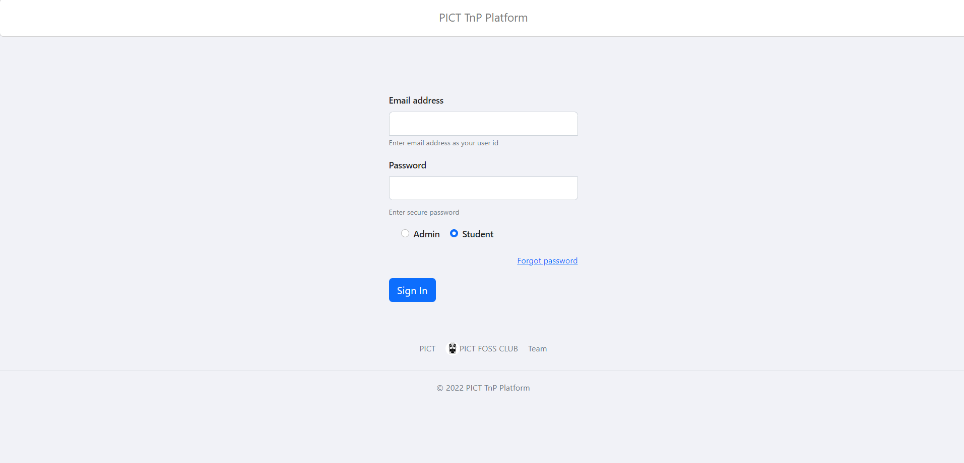

**ADMIN DASHBOARD –**

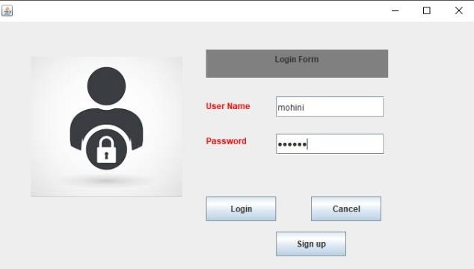

**ADMIN STUDENT LIST –**

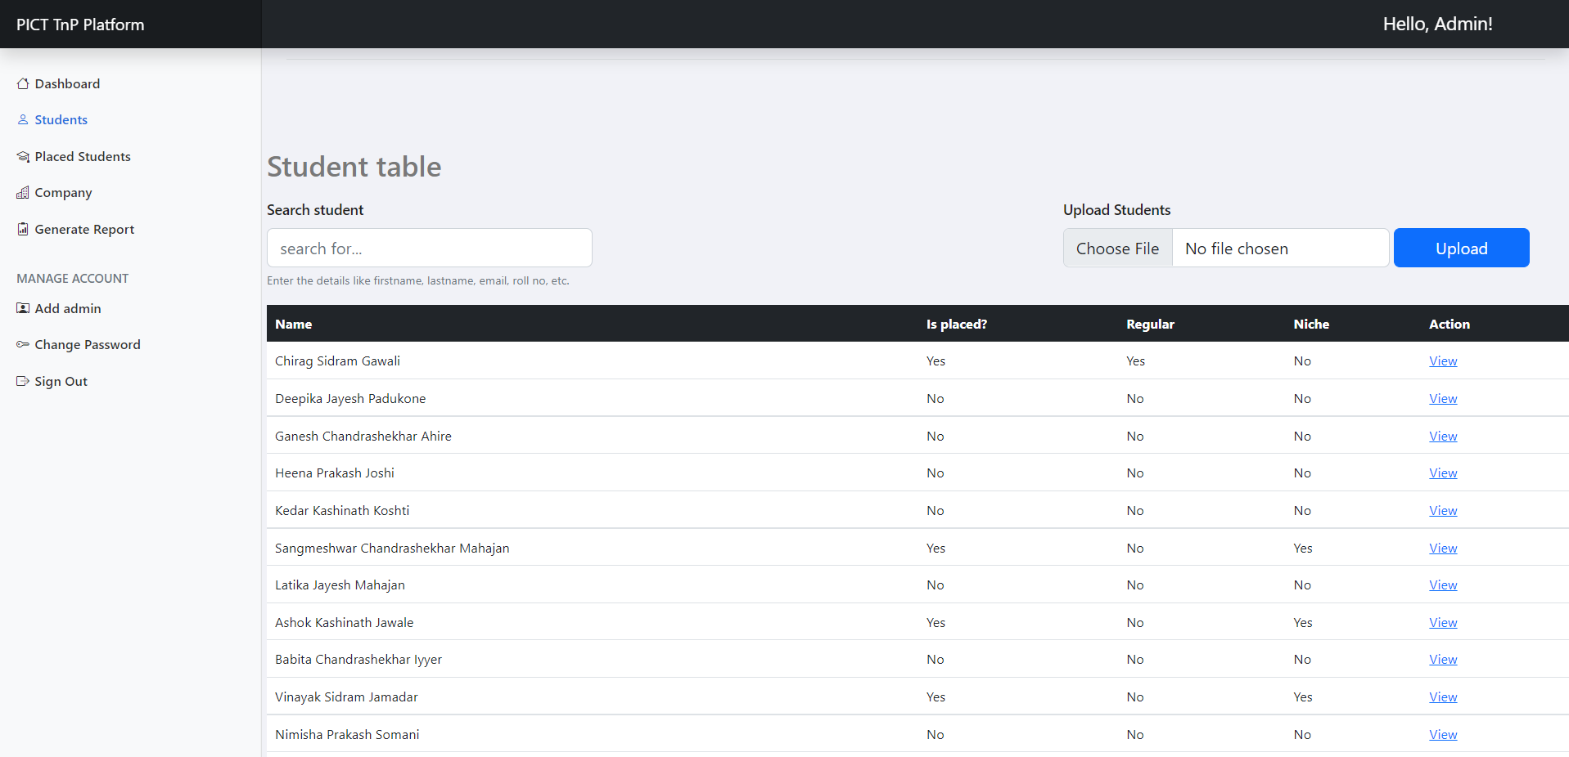

# 

**ADMIN PLACED STUDENT LIST –**

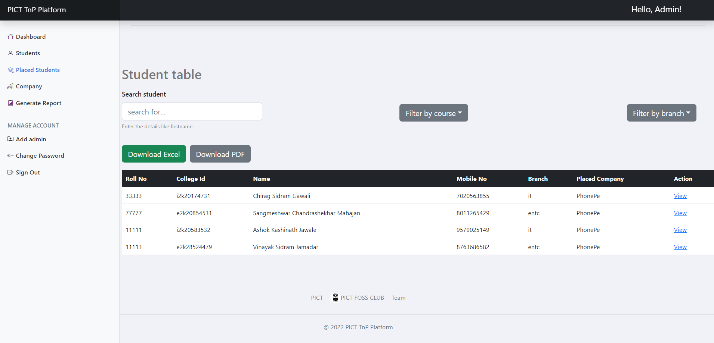

**ADMIN COMPANY LIST –**

**GENERATE REPORT –**

**STUDENT DASHBOARD –**

# ADMIN STUDENT PROFILE –

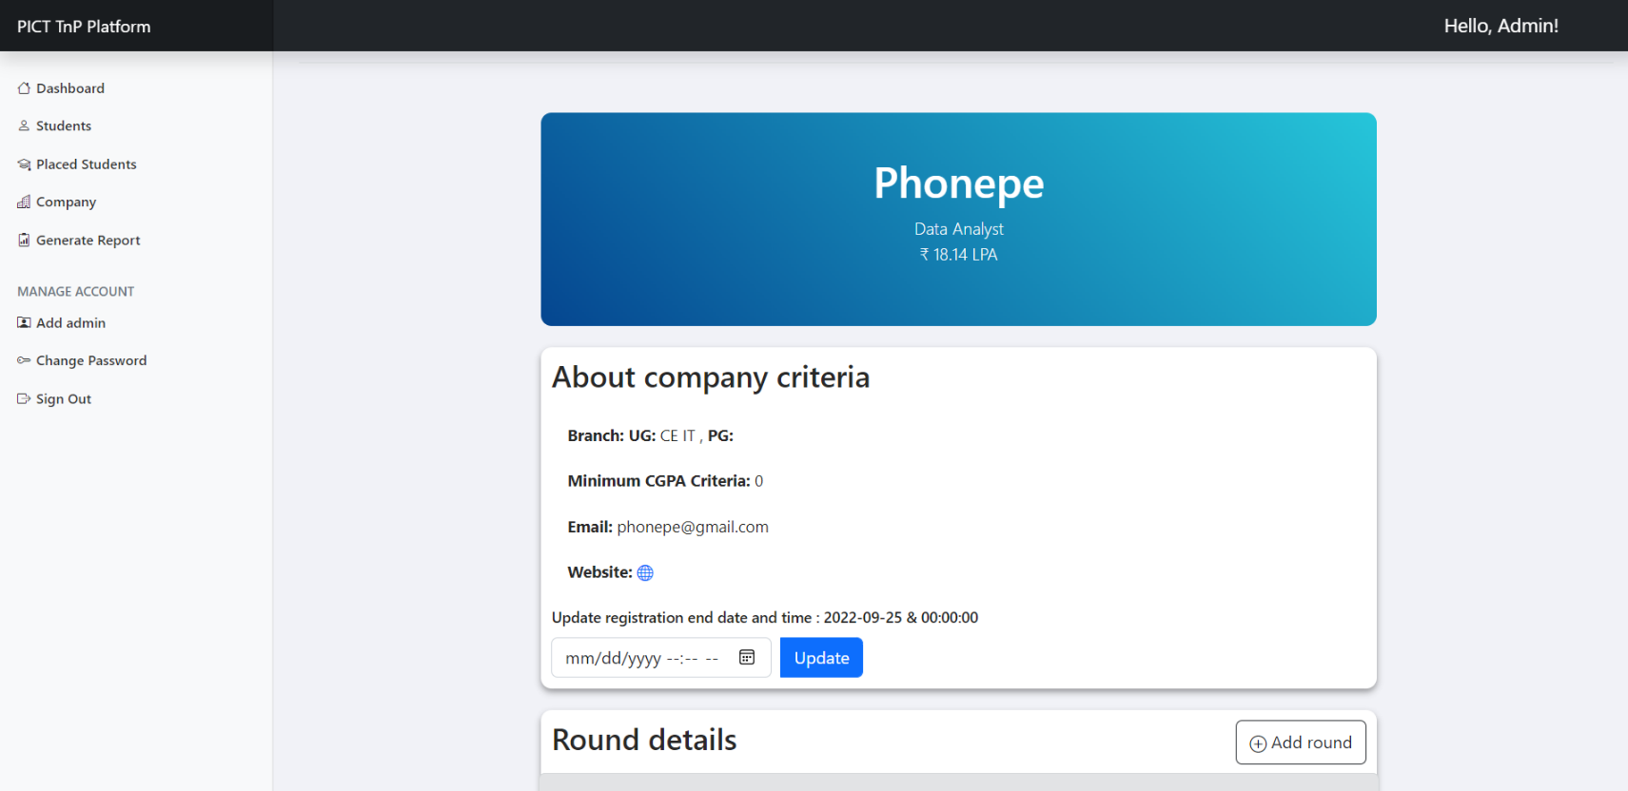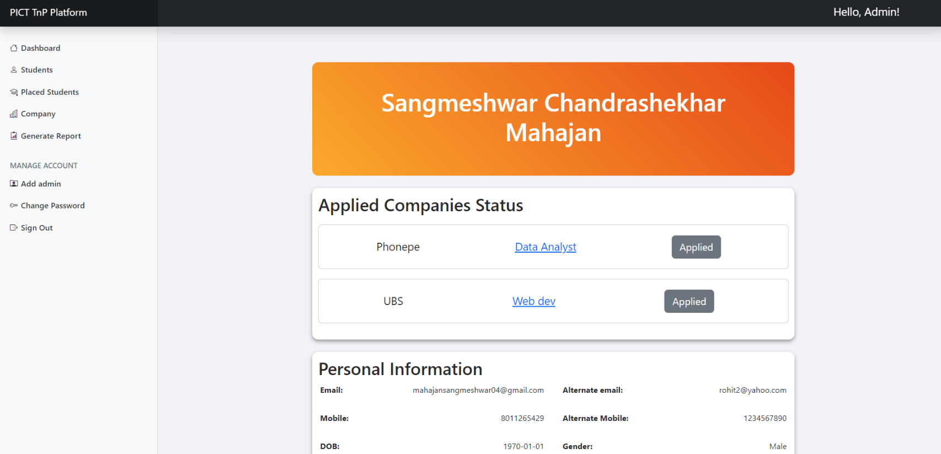**ADMIN COMPANY PROFILE –**

**STUDENT COMPANY LIST**

**STUDENT COMPANY PROFILE/JD**

# CHAPTER 6 CONCLUSION & FUTURE ENHANCEMENTS

**6.1 CONCLUSION**

Hence, we have successfully built an application that intended to help to admin and students for throughout their placement season. We took help all concept of MongoDB in Database Management System. Also, we have a pretty interface to provide a window to make changes, so the application becomes a dynamic one.

**6.2 FUTURE ENHANCEMENTS**

* To add Automated Reports generation module so the manual work can be reduced till some extent.
* Maintaining the resume of students and sending them to companies and filtering them according to some criteria.